1 Sample Code from Assignment



2. Connect to Ubuntu Server with Credentials and show IP

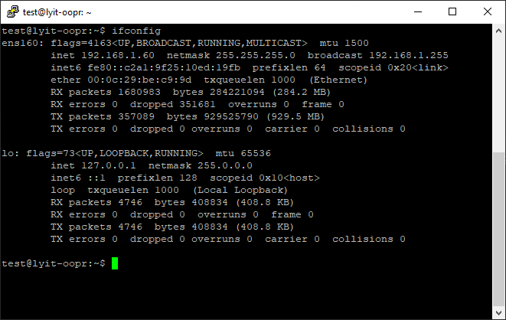

3. List Directories to show nothing created before Script

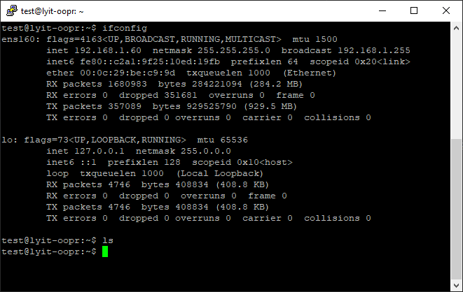

4 Run Curl Command to show Curl is not preinstalled

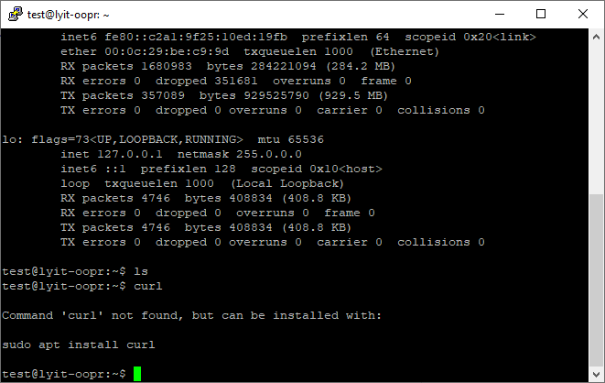

5 Run Code

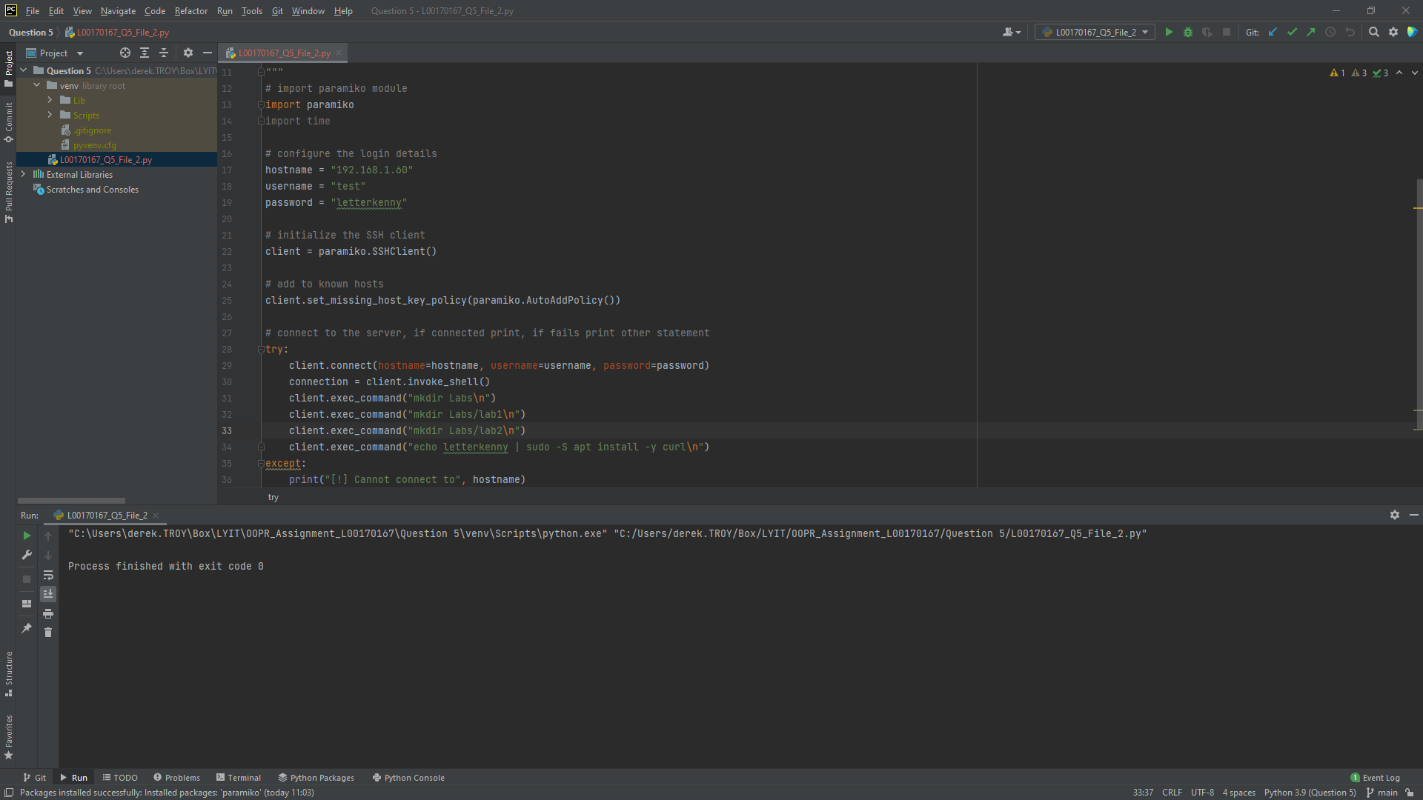

6 Check for Directories

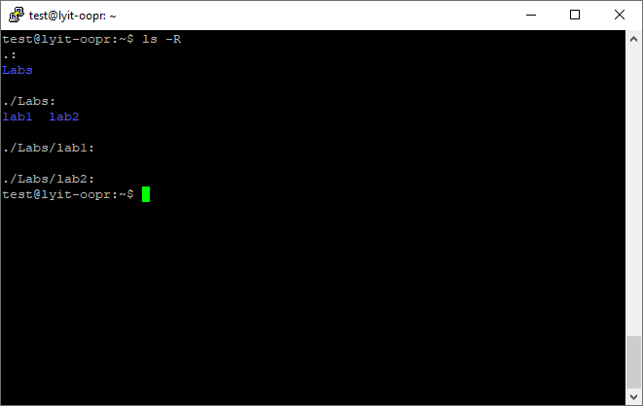

7 Check to see if Curl has installed

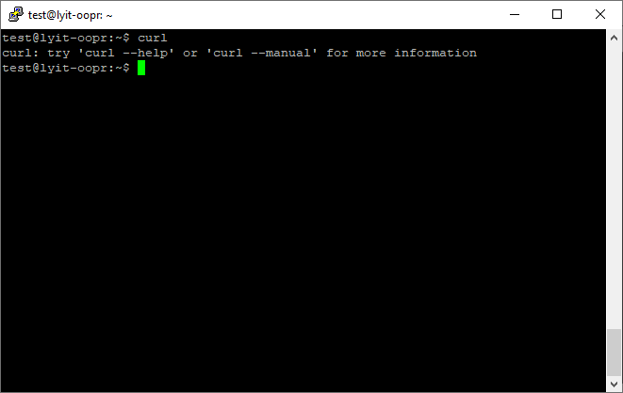

8 Run extra command ls -l –time=atime to show last accessed directories

